1)Top 5 highest salary employees
SELECT emp_id, emp_name, salary
FROM emp
ORDER BY salary DESC
LIMIT 5;
Output:


2)Department wise employee count
SELECT dept_id, COUNT(*)
FROM emp
GROUP BY dept_id;

Output:


3)Find second highest salary
SELECT MAX(salary)
FROM emp
WHERE salary < (SELECT MAX(salary) FROM emp);
Output:


4)Employees whose salary > department average salary
SELECT *
FROM emp e
WHERE salary >
(
SELECT AVG(salary)
FROM emp
WHERE dept_id = e.dept_id
);
Output:
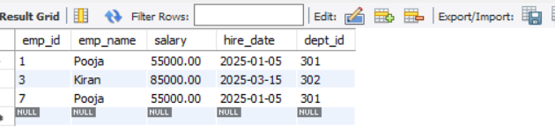

5)Inner Join
SELECT e.emp_name, d.dept_name
FROM emp e
INNER JOIN dept d
ON e.dept_id = d.dept_id;

Output:
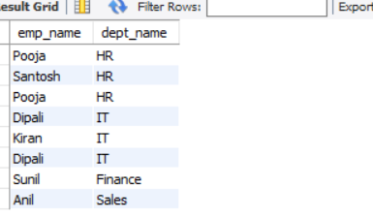

6)Left Join
SELECT e.emp_id, d.dept_name
FROM emp e
LEFT JOIN dept d
ON e.dept_id = d.dept_id;

Output:

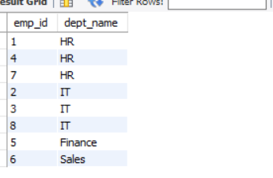

7)Group By with Having
SELECT dept_id, COUNT(*) AS total_employees
FROM emp
GROUP BY dept_id;

Output:
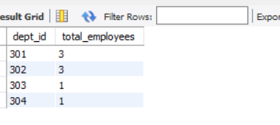

8)Employees hired in last 6 months
SELECT *
FROM emp
WHERE hire_date >= CURRENT_DATE - INTERVAL 6 MONTH;
Output:


9)Find the Duplicate Records
SELECT emp_name, COUNT(*) AS cnt
FROM emp
GROUP BY emp_name
HAVING COUNT(*) > 1;
Output:


10)How To Remove duplicates record
DELETE e1
FROM emp e1
JOIN emp e2
ON e1.emp_name = e2.emp_name
AND e1.emp_id > e2.emp_id;

Output:
